

Foundations of Programming

Assignment No. : 03

PROBLEM STATEMENT:
Write a program in C to generate multiplication tables for a given number.

OBJECTIVES:
To understand the use of looping statements in C.
To generate multiplication tables using loops.
To improve program logic and execution flow understanding.

THEORY:
Syntax for for loop example program
Syntax for while loop example program
Syntax for do while loop example program

ALGORITHM:
- START
- Declare variables
- n → to store the given number
- i → loop counter
- Read the value of n
- Set i = 1
- While i ≤ 10
- Calculate result = n × i
- Display n × i = result
- Increment i by 1
- STOP

CODE:
#include <stdio.h>

int main() {
int n, i;

printf("Enter a number: ");
scanf("%d", &n);

for(i = 1; i <= 10; i++) {
printf("%d x %d = %d\n", n, i, n * i);
}

return 0;
}

FLOWCHART:
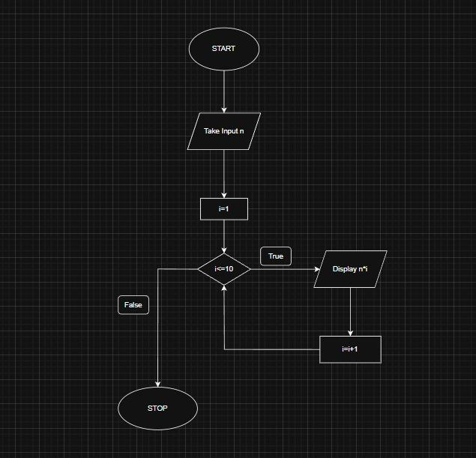

INPUT:
Choice of operation and two numbers
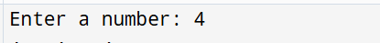

OUTPUT:
Displays the result of the selected arithmetic operation
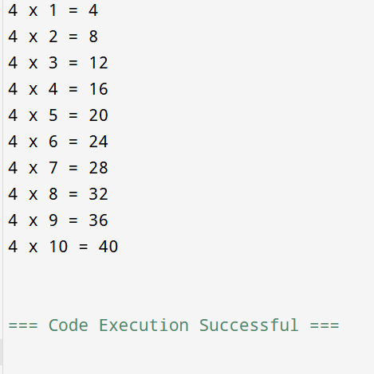

CONCLUSION:
Thus, the menu driven program in C successfully performs basic arithmetic operations using switch–case statements.

